WEEK OF MAR. 22ND – MAR. 28TH

Last week’s meet was incredible!! Great Oak has always been one of our biggest competitors. Our Varsity Girls team was within 2 points of tying for victory, when the gap is usually about 40. Great swims by ALL swimmers! They really rose to the occasion! They rose so high, that some achieved bettering their already amazing CIF cuts, and we had a few new ones as well!

ISABELLA ALVAREZ: 100 FREE
DJ BLACKBURN: 100 FLY
WILLIAM MARTIN: 200 FREE

WAY TO GO BRONCOS!!!

This week we have a League meet against another major competitor, Murrieta Valley, Wed 3/25th AT MV high school. Please come out again in Bronco fashion and cheer on our swimmers!!!

We are going to be catering the banquet this year. The cost will be $20 per family. We will need a head count as to how many people will be attending to give to the caterers. Please email or text April, DJ’s mom, with your head count. Include your swimmer(s) name and how many. We do have a few families with multiple swimmers, so here’s an example (Ex: – DJ/4 or Alvarez kids/6)
doggies4@verizon.net or 951-445-8460
More info to follow and also where to send payment.

SWIMMER’S OF THE WEEK
Our first swimmer of the week is Matthew Talavera. Matthew constantly pushes himself to improve every day and is always focused during practice, listening carefully and doing exactly what he is asked. His dedication is clear, always showing up to practice and showing a real commitment to the team. Recently being moved up to Varsity highlights how much is hard work has paid off. On top of that, Matthew is kind and respectful to everyone, making him not only a strong swimmer, but also a great teammate. Congratulations on being Swimmer of the Week!


Our second swimmer of the week is Julia Villegas. Julia has shown incredible dedication and commitment both in and out of the pool. She consistently goes above and beyond, putting in extra work to improve her skills and pushing herself to reach new goals. Whenever she is swimming, she gives it her all, demonstrating focus, determination, and the drive to succeed. Her effort and persistence make her stand out on the team, and it’s clear that her hard work is paying off. Congratulations Julia on being Swimmer of the Week!
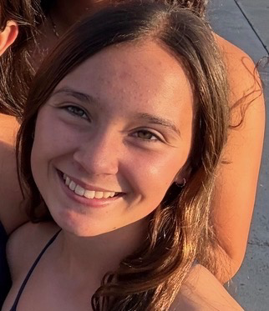

THIS WEEK’S SCHEDULE

3/23 Mon – JV/VAR 3:30-5:30p
NOVICE 4-5:30p

3/24 Tues. - JV/VAR 6th-4p
After school 3:30-5:30p
NOVICE 4-5:30p

**3/25 Wed – MEET @ MURRIETA VALLEY @4p
VAR/ JV EARLY RELEASE 1:30
BE AT MV BY 2:50p
*NO NOVICE PRACTICE*

3/26 Thurs – JV/VAR 6th-4p
After school 3:30-5:30p
NOVICE 4-5:30p

3/27 Fri – JV/VAR 3:30-5:30
**NOVICE 4-5:30p**

HAVE AN AMAZING WEEK!!

