WEEK OF MAY 3rd – MAY. 9th

Last week our JV & Varsity teams competed in their final meets of the season, League Finals. Our JV Girls came away with 2nd place, while the Boys came away with 4th. Our Varsity Girls came away with a 3rd place win, while our boys came away with 5th. ALL SWIMMERS DID EXCEPTIONALY WELL!! We had bettered CIF cuts and Aiden Abalos crushed his 100 breaststroke for a 3rd record breaking time of 59.61.

**This week, those on Varsity who made CIF cuts will participate in Prelims & Finals @ MT SAC.
Boys-
Prelims – Tues 5/5 9a-1p. Arrival time @ 7a
Finals – Thurs 5/7 4p-8p. Arrival time @ 1:45p
Girls-
Prelims – Wed 5/6 4p-8p. Arrival time @ 1:45p
Finals – Frid 5/8 3p-7p. Arrival time @ 1:30p
Keep up the great work Broncos and swim FAST!!!

Our end of season banquet is May 21st. If you have not already done so, please sign up for the banquet through sign up genius that was sent out on remind.

SWIMMER’S OF THE WEEK

Our first swimmer of the week is Isabella Alvarez. Isa has really shown how dedicated and hard-working she is as both the swimmer and a teammate. She puts her all into the sport every single day, always pushing herself to improve. She especially stands out with her backstroke, where her skill and effort really show. On top of that, she’s incredibly committed, and never gives up, always trying to get better while helping others to improve as well. Overall, she truly deserves swimmer of the week for her effort, positivity, and dedication. Congratulations Isa on being one of this week’s swimmer of the week!


Our second swimmer of the week is Aiden Abalos. Aidan is fully focused on achieving his best times and pushing himself beyond his limits. His dedication to the sport drives him to give his all in every race. That has been proven this season with his multiple CIF cuts and breaking 2 records that have not been broken since 2015 and 2009. By staying committed and challenging himself to improve, Aiden embodies a swimmers attitude with his passion and a relentless pursuit of personal excellence. Congratulations Aiden on being one of this week’s swimmer of the week!
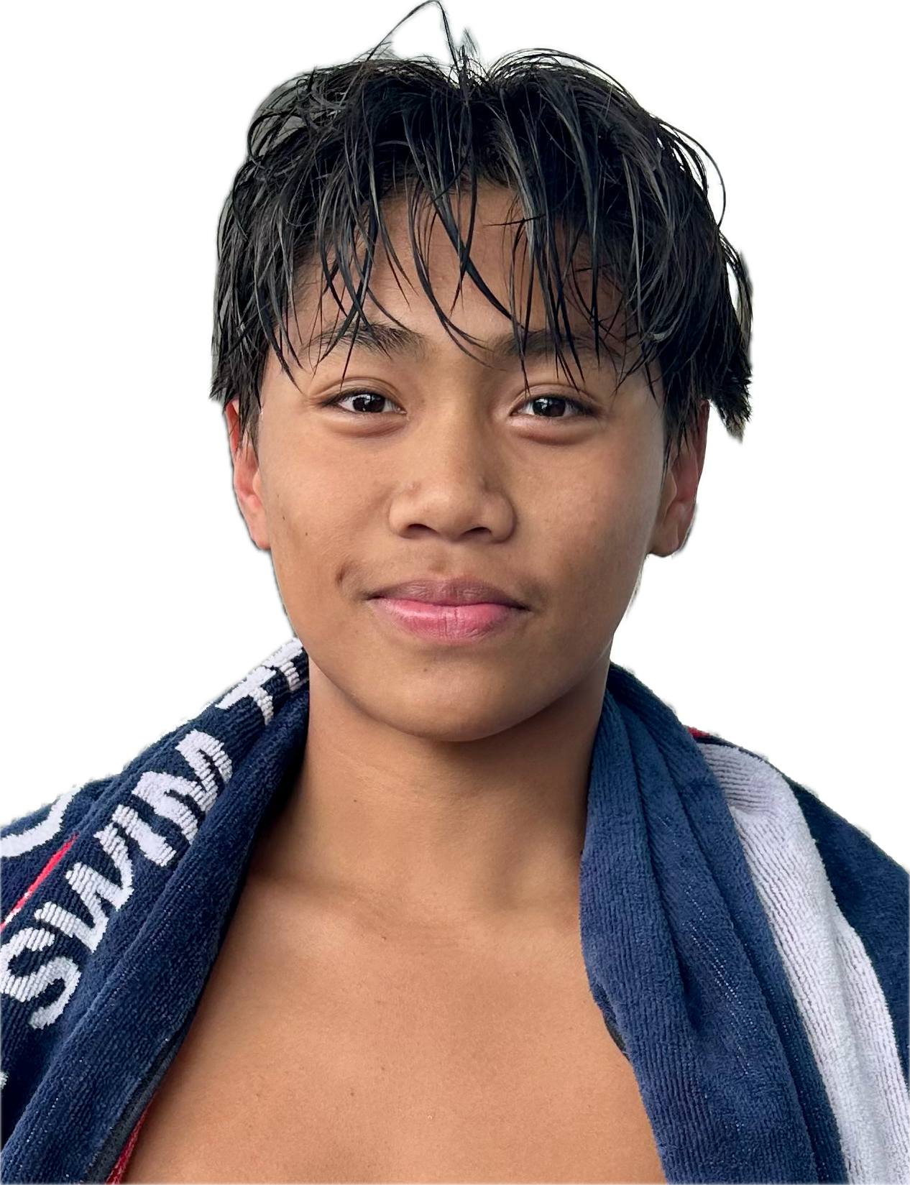

THIS WEEK’S SCHEDULE
VAR (NOT GOING TO CIF)/JV & NOVICE – NO AFTER SCHOOL PRACTICE
IF YOU ARE IN 6TH PERIOD, WE STILL GET IN THE WATER & SWIM. THIS IS A PARTICIPATION CLASS & YOU MUST PARTICIPATE.

5/4 Mon –
6TH -3:30
CIF swimmers & alt’s

5/5 Tues –
**Boys CIF Prelims @ MT SAC**
Arrive @ MT SAC 7a
Warm-ups @ 7:15a
Meet start time @ 9a

Girls CIF swimmers/alt’s
After school – 3:30-4:30-ish w/ Coach Bridgette

5/6 Wed –
**Girls CIF Prelims @ MT SAC**
Early release @ 11:30a
Arrive @ MT SAC 1:45p
Warm-ups @ 2p
Meet start time @ 4p

Boys CIF swimmers/alt’s – 6th-3:30
w/ Coach Bridgette

5/7 Thurs –
**Boys CIF Finals @ MT SAC**
Early release @ 11:30a
Arrive @ MT SAC 1:45p
Warm-ups @ 2p
Meet start time @ 4p

Girls CIF swimmers/alt’s
After school – 3:30-4:30-ish w/ Coach Bridgette

5/8 Fri –
**Girls CIF Finals @ MT SAC**
Early release @ 11:00a
Arrive @ MT SAC 12:45p
Warm-ups @ 1p
Meet start time @ 3p
6TH period – 3:30 w/ Coach Bridgette

HAVE A GREAT WEEK &
GOOD LUCK AT CIF!!!
SWIM FAST BRONCOS!!!

